**ASSIGNMENT-1**

**Domain:** IoT

**Assignment** on **SMART HOME AUTOMATION IN TINKERCAD**

**Team Members:**

SUBALAKSHMI G-513119106314

RANJITH KUMAR R-513119106311

TAMIZH D-513119106316

VELMURUGAN V-513119106317

**CIRCUIT:**

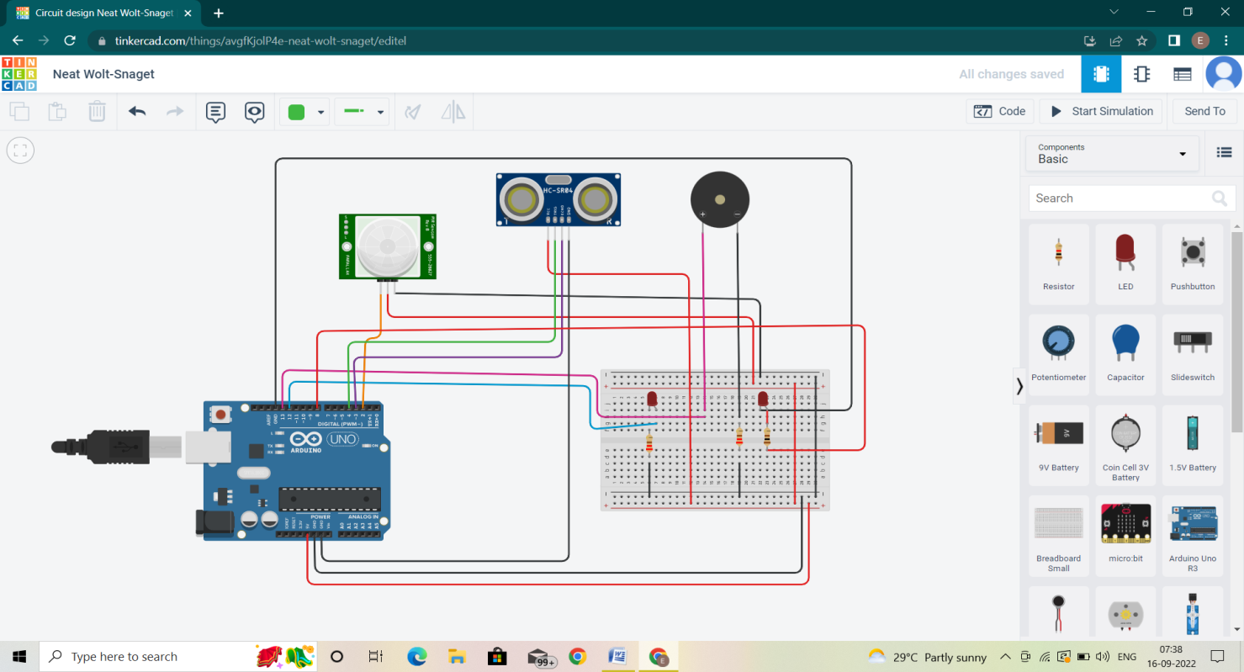

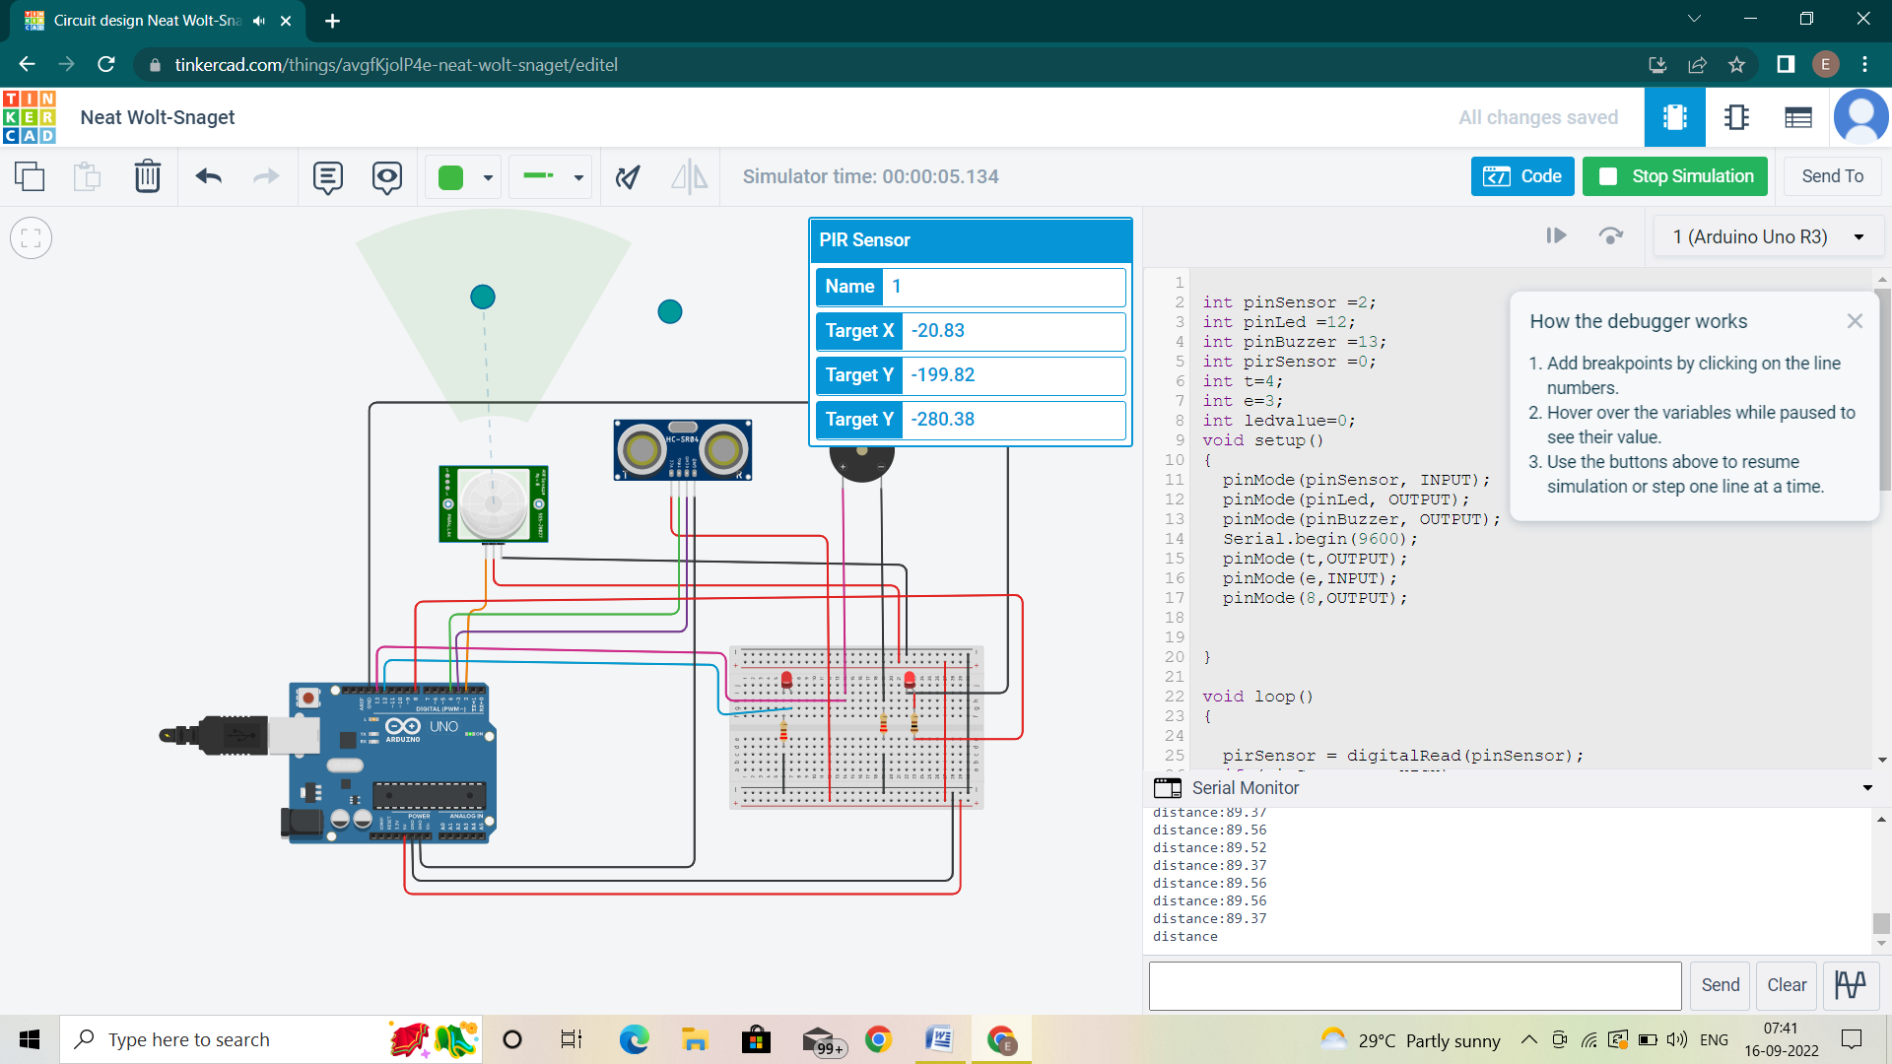

**Components used:**

|  |  |  |
| --- | --- | --- |
| **Name** | **Quantity** | **Components** |
| U1 | 1 | Arduino Uno R3 |
| PIR1 | 1 | -20.8374493192873,-199.82134232419207,-280.3753125931,-269.74676887641135 PIR Sensor |
| D1  D2 | 2 | Red LED |
| R1  R2 | 2 | 220 Ω Resistor |
| PIEZO1 | 1 | Piezo |
| DIST 1 | 1 | Ultrasonic Distance Sensor |
| R3 | 1 | 100Ω Resistor |

**Code:**

intpinSensor =2;

intpinLed =12;

intpinBuzzer =13;

intpirSensor =0;

int t=4;

int e=3;

intledvalue=0;

void setup()

{

pinMode(pinSensor, INPUT);

pinMode(pinLed, OUTPUT);

pinMode(pinBuzzer, OUTPUT);

Serial.begin(9600);

pinMode(t,OUTPUT);

pinMode(e,INPUT);

pinMode(8,OUTPUT);

}

void loop()

{

pirSensor = digitalRead(pinSensor);

if (pirSensor == HIGH)

{

digitalWrite(pinLed, HIGH);

tone(pinBuzzer, 1000, 500);

}

else {

digitalWrite(pinLed, LOW);

}

delay(10);

{

digitalWrite(t,LOW);

digitalWrite(t,HIGH);

delayMicroseconds(10);

digitalWrite(t,LOW);

floatdur=pulseIn(e,HIGH);

float dis=(dur*0.0343/2);

Serial.print("distance:");

Serial.println(dis);

ledvalue = map(dis,330,10,0,255);

analogWrite(8,ledvalue);

}

}

**Tinkercad Link:**

[**https://www.tinkercad.com/things/avgfKjolP4e-neat-wolt-snaget**](https://www.tinkercad.com/things/avgfKjolP4e-neat-wolt-snaget)